*BAB 11*;

LIBNAME ORION "C:\Users\User\Desktop\SAS\P1 DATA & PROG (1)\P1 DATA";

*SUITABLE FOR GROUPING VARIABLE,TABLE GENDER,VARIABLE MANA YG KITA NAK KELUARKAN*;

**proc** **freq** data=orion.sales;

tables Gender;

where Country='AU';

**run**;

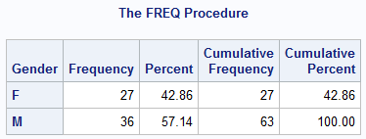

*NOCUM :SUPPRESSES THE CUMULATIVE STATISTICS

NOPERCENT: SUPPRESSES THE PERCENTAGE DISPLAY*;

**proc** **freq** data=orion.sales;

tables country / nocum nopercent;

**run**;

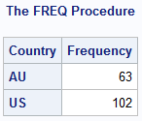

**proc** **freq** data=orion.sales;

tables Gender Country;

**run**;

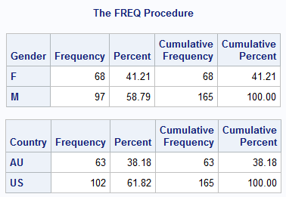

**proc** **freq** data=orion.sales;

tables Gender Country;

**run**;

**DIA AKAN KELUAR SEMUA**

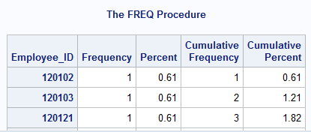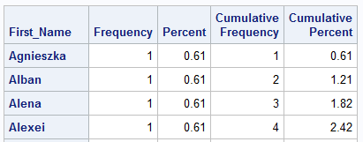

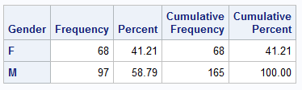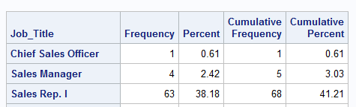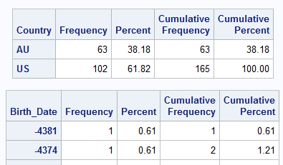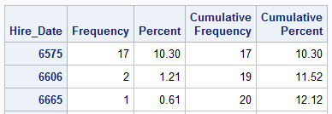

**THESE VARIABLES NOT SUITABLE FOR A FREQUENCY ANALYSIS BECAUSE IT CAN EXPAND THE UNIT OR ELEMENT. BUT FOR GENDER,CAN.**

*IF NAK GUNA BY MUST USE PROC SORT FIRST, BY KENA ADA UTK DUA2 DALAM PROC SORT AND PROC FREQ*;

**proc** **sort** data=orion.sales out=sorted;

by Country;

**run**;

**proc** **freq** data=sorted;

tables Gender;

by Country;

**run**;

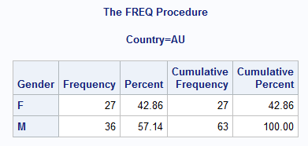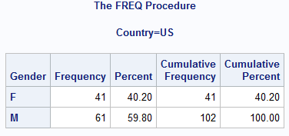

*TANDA ASTERISK BETWEEN TWO VARIABLES GENERATES A TWO-WAY FREQUENCY TABLE, OR CROSSTABULATION TABLE*;

**proc** **freq** data=orion.sales;

tables Gender*Country;

**run**;

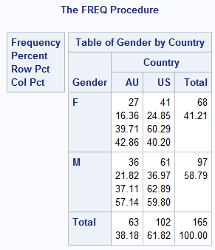

ROW PCT:ROW PERCENT

68: NOFREQ SUPPRESSES : SUPPRESSES THE FREQUENCY DISPLAY

41.21: NOPERCENT SUPPRESSES : SUPPRESSES THE PERCENTAGE DISPLAY

57.14 : NOCOL SUPPRESSES : SUPPRESSES THE DISPLAY OF THE COLUMN PERCENTAGE

39.71 : NOROW SUPPRESSES : SUPPRESSES THE DISPLAY OF THE ROW PERCENTAGE

**proc** **freq** data=orion.sales;

tables Gender*Country / NOROW NOCOL;

**run**;

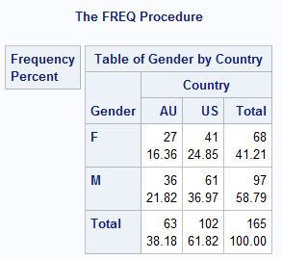

**proc** **freq** data=orion.sales ;

tables Gender*Country / list;

**run**;

DIA AKAN BUAT HORIZONTAL

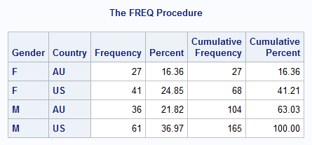

**proc** **freq** data=orion.sales;

tables Gender*Country / crosslist;

**run**;

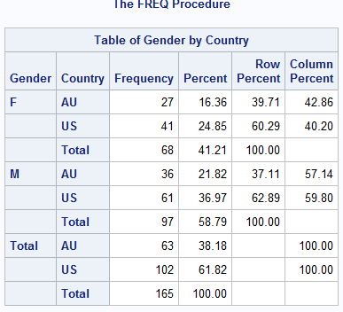

**PROC** **PRINT** DATA=ORION.NONSALES2;

**RUN**;

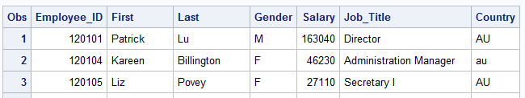

*DISPLAY ALL DISCRETE VALUES FOR A VARIABLE AND REPORTS MISING VALUE*;

**proc** **freq** data=orion.nonsales2;

tables Gender Country / nocum nopercent;

**run**;

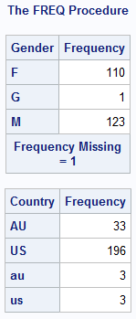

*NLEVELS DISPLAY A TABLE THAT PROVIDE THE NUMBER OF DISTINCT VALUES FOR EACH ANALYSIS VARIABLE*;

**proc** **freq** data=orion.nonsales2 nlevels;

tables Gender Country / nocum nopercent;

**run**;

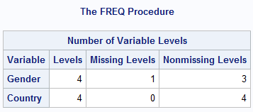

*THE VALUE OF EMPLOYEE_ID MUST BE UNIQUE AND NOT MISSING

THE ORDER=FREQ DISPLAY IN DESCENDING ORDER*;

**proc** **freq** data=orion.nonsales2 order=freq;

tables Employee_ID / nocum nopercent;

**run**;

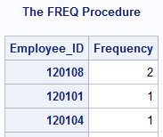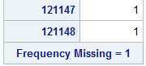

*NLEVELS TU NK TAHU ADE DUPLICATE TAK*;

**proc** **freq** data=orion.nonsales2 nlevels;

tables Employee_ID / noprint;

**run**;

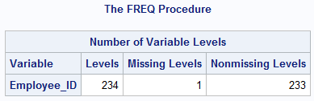

ADA 1 DUPLICATE DAN 1 MISING VALUE.

DATA ASAL ADE 235.

**proc** **freq** data=orion.nonsales2 nlevels;

tables _all_ / noprint;

**run**;

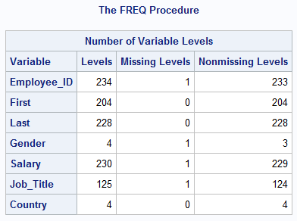

NO FREQUENCY TABLE DISPLAYED

**proc** **freq** data=orion.nonsales2;

tables Job_Title / nocum nopercent;

**run**;

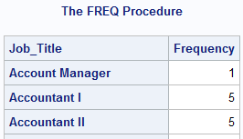

PROC FREQ UNCOVERED THE EXISTENCE OF INVALID DATA FOR GENDER ,COUNTRY AND EMPLOYEE_ID.

**proc** **print** data=orion.nonsales2;

where gender not in ('F','M') or

country not in ('AU','US') or

job_title is null or

employee_id is missing or

employee_id=**12018**;

**run**;

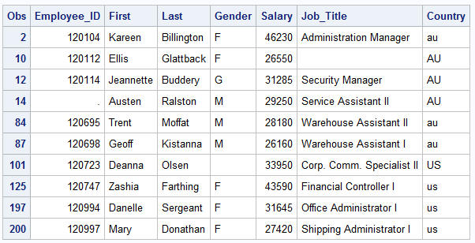

**proc** **freq** data=orion.sales;

tables Hire_Date / nocum;

format Hire_Date date9.;

**run**;

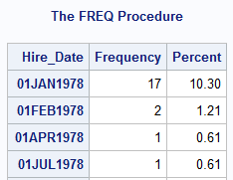

**proc** **freq** data=orion.sales;

tables Hire_Date / nocum;

format Hire_Date year4.;

**run**;

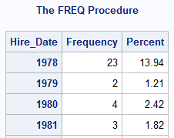

**proc** **freq** data=orion.sales;

tables Gender*Country;

**run**;

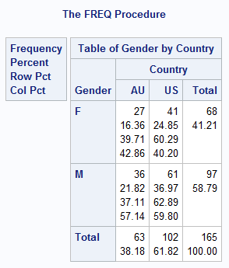

**proc** **format**;

value $ctryfmt 'AU'='Australia'

'US'='United States';

value $gender 'F'='Female'

'M'='Male';

**run**;

**proc** **freq** data=orion.sales;

tables Gender*Country;

format Country $ctryfmt.

Gender $gender.;

**run**;

SEPATUTNYA NAMA COUNTRY TU JADI Australi a United S tates;

Column dio jadi rapat.

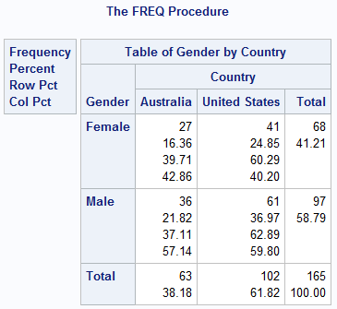

LEPAS GUNA PROC FORMAT TU COLUMNS ARE 13 CHARACTER WIDE.

**proc** **freq** data=orion.sales;

tables Gender*Country / format=**13.**;

format Country $ctryfmt.

Gender $gender.;

**run**;

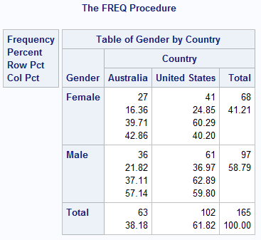

Cari google file chapter 28, the freq prodedure. <http://www.math.wpi.edu/saspdf/stat/chap28.pdf>

Sbb benda ni mungkin guna masa hadapan.

*11.2 the means and univariate procedures*;

<https://support.sas.com/resources/papers/proceedings/proceedings/sugi29/240-29.pdf>

<https://stats.idre.ucla.edu/wp-content/uploads/2016/02/p068.pdf>

<https://www.lexjansen.com/nesug/nesug08/ff/ff06.pdf>

<http://www.sascommunity.org/mwiki/images/a/a7/PROC_MEANS_Basics_and_Beyond_for_Gary_Oct_2011.pdf>

Only cover for numeric variable

**proc** **means** data=orion.sales;

**run**;

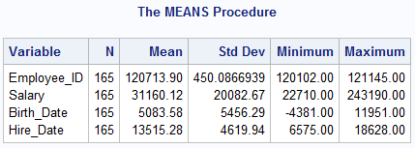

**proc** **means** data=orion.sales;

var Salary;

**run**;

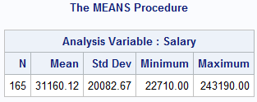

**proc** **means** data=orion.sales n mean;

var Salary;

**run**;

VAR ARE THE NUMERIC VARIABLES

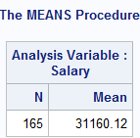

**proc** **means** data=orion.sales;

var Salary;

class Gender Country;

**run**;

CLASS ARE VARIABLES WHOSE VALUES DEFINE SUBGROUPS FOR THE ANALYSIS.CAN BE CHAR OR NUMERIC

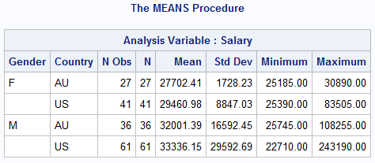

N obs -THE NUMBER OF OBSERVATIONS WITH EACH UNIQUE COMBINATION OF CLASS VARIABLES

N- THE NUMBER OF OBSERVATIONS WITH NONMISSING VALUES OF THE ANALYSIS VARIABLE (OR VARIABLES).

*nmiss bermaksud non missing value*;

**proc** **means** data=orion.sales nmiss min max sum;

var Salary;

class Gender Country;

**run**;

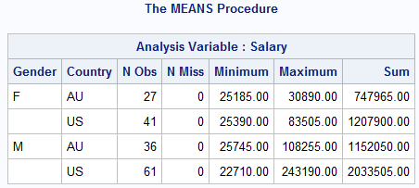

**proc** **means** data=orion.sales nmiss min max maxdec=**1**;

var Salary;

class Gender Country;

**run**;

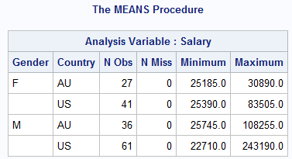

**proc** **means** data=orion.sales nmiss min max maxdec=**0**;

var Salary;

class Gender Country;

**run**;

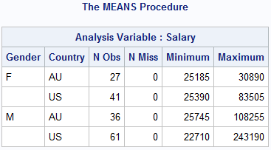

**proc** **means** data=orion.sales nmiss min max nonobs;

var Salary;

class Gender Country;

**run**;

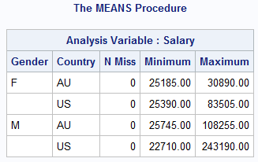

**proc** **means** data=orion.sales nmiss min max nonobs;

var Salary;

class Gender Country;

**run**;

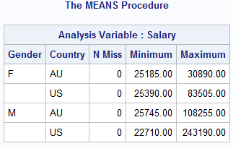

**proc** **univariate** data=orion.nonsales2;

var Salary;

**run**;

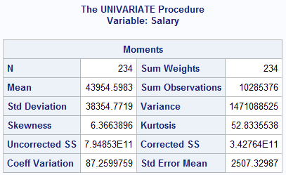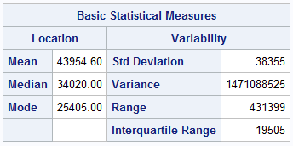

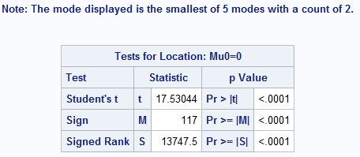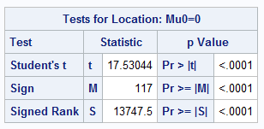

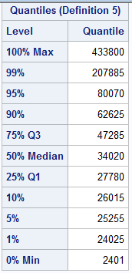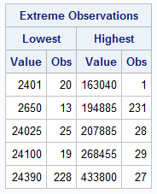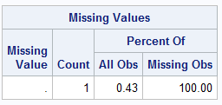

**proc** **univariate** data=orion.nonsales2 nextrobs=**3**;

var Salary;

**run**;

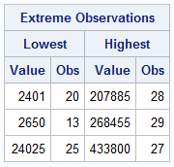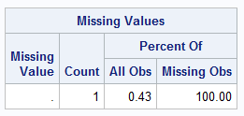

**proc** **univariate** data=orion.nonsales2;

var Salary;

id Employee_ID;

**run**;

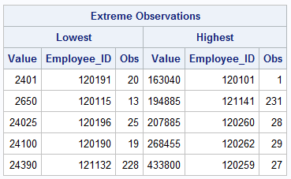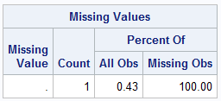

options nodate nonumber;

title; footnote;

ods html file="C:\Users\User\Desktop\SAS\P1 DATA & PROG (1)\P1 DATA\myreport.html";

**proc** **freq** data=orion.sales;

tables Country;

**run**;

ods html close;

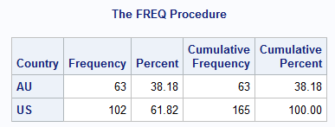

options nodate nonumber;

title; footnote;

ods html file="C:\Users\User\Desktop\SAS\P1 DATA & PROG (1)\P1 DATA\example.html";

ods pdf file="C:\Users\User\Desktop\SAS\P1 DATA & PROG (1)\P1 DATA\example.pdf";

ods rtf file="C:\Users\User\Desktop\SAS\P1 DATA & PROG (1)\P1 DATA\example.rtf";

**proc** **freq** data=orion.sales;

tables Country;

**run**;

**proc** **means** data=orion.sales;

var Salary;

**run**;

ods html close;

ods pdf close;

ods rtf close;

*ods _all_ close;

*ods html;

options nodate nonumber;

title; footnote;

options nodate nonumber;

title; footnote;

ods html file="C:\Users\User\Desktop\SAS\P1 DATA & PROG (1)\P1 DATA\example.html";

ods pdf file="C:\Users\User\Desktop\SAS\P1 DATA & PROG (1)\P1 DATA\example.pdf";

ods rtf file="C:\Users\User\Desktop\SAS\P1 DATA & PROG (1)\P1 DATA\example.rtf";

**proc** **freq** data=orion.sales;

tables Country;

**run**;

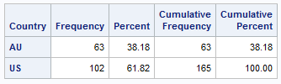

**proc** **means** data=orion.sales;

var Salary;

**run**;

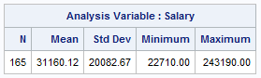

ods html close;

ods pdf close;

ods rtf close;

*ods _all_ close;

*ods html;

ods listing file="C:\Users\User\Desktop\SAS\P1 DATA & PROG (1)\P1 DATA\myreport.txt";

**proc** **print** data=orion.sales;

**run**;

ods close;

options nodate nonumber;

title; footnote;

ods html file="C:\Users\User\Desktop\SAS\P1 DATA & PROG (1)\P1 DATA\myreport1.html" style=htmlblue;

**proc** **freq** data=orion.sales;

tables Country;

**run**;

ods html close;

ods html file="C:\Users\User\Desktop\SAS\P1 DATA & PROG (1)\P1 DATA\myreport2.html" style=default;

**proc** **freq** data=orion.sales;

tables Country;

**run**;

ods html close;

ods html file="C:\Users\User\Desktop\SAS\P1 DATA & PROG (1)\P1 DATA\myreport3.html" style=sasweb;

**proc** **freq** data=orion.sales;

tables Country;

**run**;

ods html close;

ods pdf file="C:\Users\User\Desktop\SAS\P1 DATA & PROG (1)\P1 DATA\myreport1.pdf" style=pearl;

**proc** **freq** data=orion.sales;

tables Country;

**run**;

ods pdf close;

ods pdf file="C:\Users\User\Desktop\SAS\P1 DATA & PROG (1)\P1 DATA\myreport2.pdf" style=printer;

**proc** **freq** data=orion.sales;

tables Country;

**run**;

ods pdf close;

ods pdf file="C:\Users\User\Desktop\SAS\P1 DATA & PROG (1)\P1 DATA\myreport3.pdf" style=journal;

**proc** **freq** data=orion.sales;

tables Country;

**run**;

ods pdf close;

ods rtf file="C:\Users\User\Desktop\SAS\P1 DATA & PROG (1)\P1 DATA\myreport1.rtf" style=rtf;

**proc** **freq** data=orion.sales;

tables Country;

**run**;

ods rtf close;

ods rtf file="C:\Users\User\Desktop\SAS\P1 DATA & PROG (1)\P1 DATA\myreport2.rtf" style=ocean;

**proc** **freq** data=orion.sales;

tables Country;

**run**;

ods rtf close;

ods rtf file="C:\Users\User\Desktop\SAS\P1 DATA & PROG (1)\P1 DATA\myreport3.rtf" style=minimal;

**proc** **freq** data=orion.sales;

tables Country;

**run**;

ods rtf close;

ods listing;

**proc** **template**;

list styles;

**run**;

ods listing close;

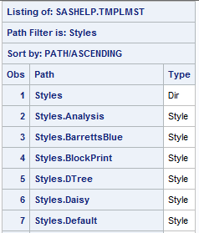

options nodate nonumber;

title; footnote;

ods csvall file="C:\Users\User\Desktop\SAS\P1 DATA & PROG (1)\P1 DATA\example.csv";

ods msoffice2k file="C:\Users\User\Desktop\SAS\P1 DATA & PROG (1)\P1 DATA\example.html";

ods tagsets.excelxp file="C:\Users\User\Desktop\SAS\P1 DATA & PROG (1)\P1 DATA\example.xml";

**proc** **freq** data=orion.sales;

tables Country;

**run**;

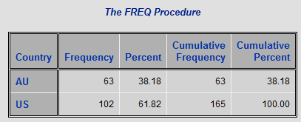

**proc** **means** data=orion.sales;

var Salary;

**run**;

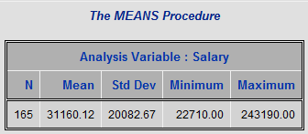

ods csvall close;

ods msoffice2k close;

ods tagsets.excelxp close;

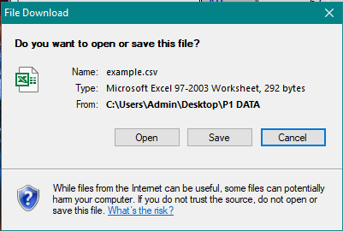

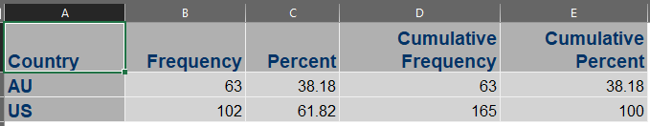

*ods _all_ close;

*ods html;

ods csvall file="C:\Users\Admin\Desktop\P1 DATA\myexcela.xls";

ods msoffice2k file="C:\Users\Admin\Desktop\P1 DATA\myexcelb.xls";

ods tagsets.excelxp file="C:\Users\Admin\Desktop\P1 DATA\myexcelc.xls";